UNIVERSITY OF PUERTO RICO

RÍO PIEDRAS CAMPUS

ENVIRONMENTAL SCIENCES DEPARTMENT

**Drought effects on the soil’s nitrogen cycle (nitrification and denitrification) of El Yunque National Rainforest, Puerto Rico.**

Edauri Navarro Pérez

Proposal

Presented as a requirement of the bachelors in Science

With a Concentration on Environmental Sciences

Approved by:



Christine O’ Connell (Mentor)

### Index

Index 2

I. Introduction 3-5

II. Methodology 5-11

A. Study Site 5-6

B.Experimental Area 6-7

C.Nitrogen Measurement 8

D. Field Schedule……………………………………………………………………....8-10

E. Data Analysis.………………………………………………………………………….11

III. References 12-13

1. **Introduction:**

The regional climate of El Yunque National Rainforest (EYNF) has become drier in the past few decades, decreasing the precipitation (~304cm/yr), increasing the effects of fire and affecting all life forms on this wet and humid forest (Jennings et al, 2013). Phenomenon such as El Niño are changing as a result of climate change (Trenberth &Hoar, 1997; Timmermann et al., 1999), increasing the climatic variation throughout the world and, specifically, increasing drought conditions in the tropics. The hydrological cycle interacts with every part of our ecosystems, being an essential factor in the formation of abiotic and biotic elements. Because of these circumstances, rainforests are changing and adapting to these new conditions of living: new water patterns and water scarcity (Wood & Silver, 2012). As an example, these situations affect the gross primary production of trees, reduce the CO2 uptake by plants and alter carbon allocation, among other impacts (Corlett, 2016). All these climatic variations and their effects can be seen in soils.

Soils are not only a big component of the lithosphere, which is a big part where the biosphere develops, but also a source of minerals and nutrients, a support for our primary producers, as well as a temperature and gas emissions regulator (Brandy & Weil, 2016). Soils are a big mediator when it comes to nutrient cycles. For example, the cycles of the most common elements in life (Carbon, Hydrogen, Oxygen, Nitrogen, Phosphorus and Sulphide) occur regularly in the lithosphere, with interactions with the others major parts of the planet, such as the hydrosphere, atmosphere and biosphere(Brandy & Weil, 2016). Nutrients have a major role in life formations, being part of every organism and non-living creation. For example, nutrients determine the fertility of a soil (Brandy & Weil, 2016), the distribution of trees (Robert et al, 2006), the wellbeing on plants, animals and more.

Increases in drought are affecting these cycles too. Water limitation to microbial activity shows that reduced precipitation may have important feedbacks altering soils greenhouse gas emissions (Davidson et al., 2004) and also have a direct effect on nutrient availability by affecting soil redox reactions (Woods & Silver, 2012). A perfect example for this is nitrogen (N). Nitrogen is one of the limiting elements in forest ecosystems, being a key part of amino acids and their transport of nutrients, metabolism control, determining seedlings amount of tissue, affecting plant height growth (Santiago et al., 2012) and the major component of the atmosphere. Because N is mostly found in inorganic form (e.g., NH4+ and NO3-), microbes and plants incorporate this element into organic matter, being useful to plants and requiring a constant N turnover, which causes an intermittent N limitation on plant growth (Ostertag, 2010).It has been shown that drought conditions can affect both of these components, increasing NO fluxes, while also decreasing nitrification, denitrification; NH4+ and N2O gas emission after extended periods of drought (Woods, 2012; Van Haren et al., 2005). These gases have a direct relationship with climate change, being greenhouse gases or promoters of it. For example, nitrous oxide (N2O) has ~300 times stronger effect on the greenhouse effect than CO2 and NO is a promoter of tropospheric ozone (Davidson et al 1993; Van Haren et al 2005). All of the consequences lead us to understand how fundamental nitrogen is in our ecosystems. Still, we know little about the complex interactions between the nitrogen cycle and drought.

This research will focus on understanding the relationship between reduced precipitation and the nitrogen cycle in El Yunque National Rainforest’s soils. Our results will help us to better understand the consequences of future climate change on this essential cycle. That is why our research question is: How does drought affect the soil nitrogen cycle on El Yunque National Forest? The null hypothesis is: If drought periods caused by climate change decrease precipitation, then nitrogen cycle transformations will decrease too. This will be done by measuring nitrate, ammonia and potential nitrification on soils extractions of the Tabonuco Forest.

1. **Methods and Materials:**
2. Study site:

Field studies were conducted on the dry season, during November 2016-March 2017 at El Verde Research Station in the Luquillo Long-Term Ecological Research Program (LTER), El Yunque National Forest (EYNF). The study was specifically in the Tabonuco Forest (18°19’N, 65°49’W). With an elevation of 420m (Gonzáles et al, 1999), the mean annual precipitation of this forest is approximately 3537mm/yr and the mean annual temperature is about 23.5°C-27°C (García et al, 1996). The type of soil that is more abundant on our study area is the ultisol (Figure 1), which is characterize by their high organic matter, clay texture and mostly located in humid environments (NRCS, 2014).

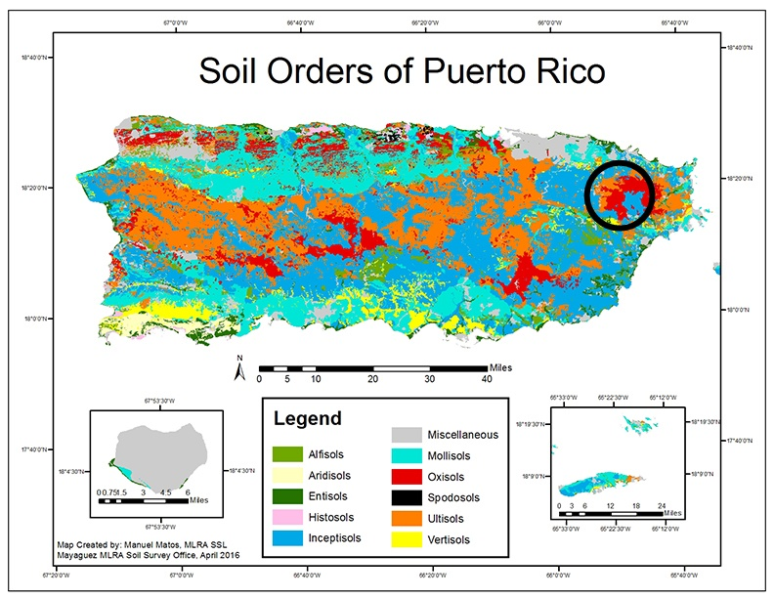

Figure 1 shows the type of soils that are present in Puerto Rico. (Matos, M, N.D.) The black circle is marking The Yunque National Forest’s area.

1. Experimental area:

An experimental drought manipulation experiment it was created to test the effects of drought on the nitrogen cycle. Our experimental plot consists on a complete through fall exclusion shelter (Figure 3) that was installed September 2016 in the forest to lower the precipitation reaching the soil system. This complete through fall exclusion was possible via transparent plastic shelters that are placed about ~ 1 above the soil, measuring an area of 11.52m2 (2.4x 4.8m). Every week the plastic shelter was turned to maintain the litter fall input in the soil. The control plot (Figure 2) did not have the through fall exclusion shelter (Guiterrez, 2016).

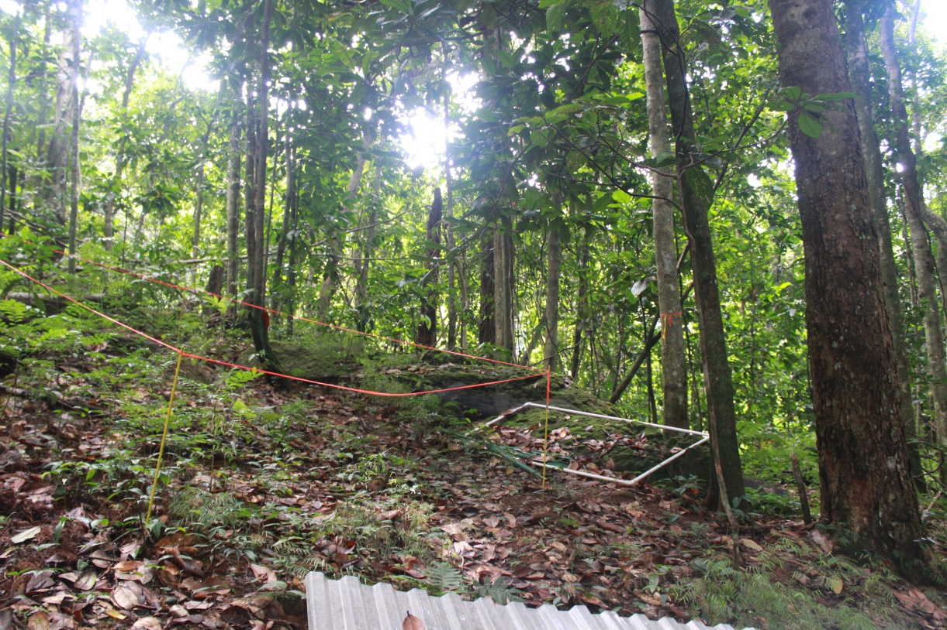

Figure 2 shows experimental area with a control plot.

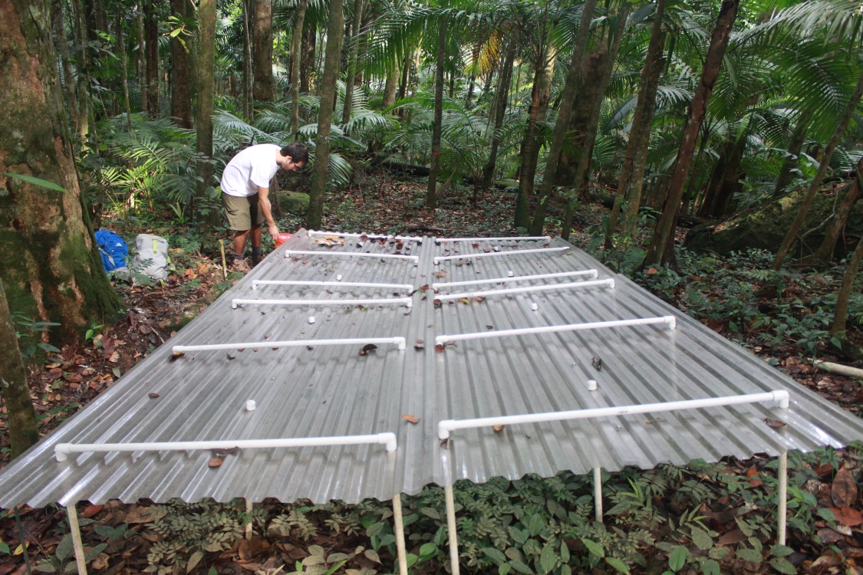

Figure 3 shows experimental area with an experimental plot.

1. Nitrogen measurement:

Automated sensors measured soil temperature and volumetric water content on each plot throughout the study period. To measure nitrification and denitrification,10 samples of 10cm soil core were taken from each plot (experimental y control), giving a total of 20 samples. Each of these samples were selected by a random distribution inside of the plot. After this, a series of chemical tests were conducted including: KCl, denitrifying enzyme activity (DEA), pH and humidity. These tests were conducted in laboratories at El Verde Field Station, USDA Forest Service, Luquillo, Puerto Rico and International Institute of Tropical Forestry, USDA, Forest Service, San Juan, Puerto Rico. Further analyses were processed at the Silver’s Lab in Berkeley, California, U.S.A. pH tests were done with 5.0g of soil and deionized water in a pre-evacuated vial. Humidity test were done with 10g of the removed soil. This soil was weighted every two days after oven incubation for a week. In total there were 3 weights, the initial wet weight and 2 dry soil weights after being in the oven. KCl extractions were used to determine NO3- and NH4+ concentrations. These were made with 25g of the sample soil and 75mL of 2M KCl solution in a specimen cup. There were 20 specimen cups of samples and 5 cups of blanks, giving a total of 25 specimen cups that were placed on a shaker for an hour. The soil extracts of these measurements were filtered by gravity.

Additionally, anaerobic conditions were created with a DEA solution and acetylene to measure the flux of nitrous oxide (N2O). The DEA solution contained 1mM glucose and 1mM potassium nitrate. This solution usually includes chloramphenicol, but it was not included because of its toxicity and the short length of the experiment. Also, it has been proven that it is not essential for a DEA (Pell et al, 2006).The DEA solution was added to a pint-sized mason jar with 25g of the soil and then sealed. This was done for every sample. To create anaerobic conditions, it was flushed with N2 for 3 minutes with a 1.5” needle. The Mason jar had another 1” needle to avoid venting problems. After this, 40mL of acetylene were injected from a gas bag to the jar and vigorously shaken by hand for 10 seconds to slurry the soil. Subsequently, the mason jars were placed in a shaker for 40 minutes. Every 10 minutes a 30mL sample of the gas from each jar was extracted and injected in a pre-evacuated vial. This process was done 4 times in total. In the Silver’s lab a denitrification potential assay was performed. This process measured what was the potential for the microbial community to denitrify labile N. All of these tests were done with Lachat**™** methods.

1. Field Schedule:

The through fall exclusion shelters, sensors and other equipment were installed since September 2016 to start creating the drought conditions. The experimental measurements were taken 6 months after, in March 10, 2017, to provid a dry experimental plot. Statistical analysis will be done during the last two weeks of March.

1. Data Analysis:

The statistical program R will be used to analyse all the results and conduct ANOVA tests. Based on the control and experimental plot, there will be 10 experimental samples and 10 control samples, measuring NO3-, NH4+, N2O concentrations, essential gases for the nitrogen cycle. With these the net nitrification rate, net N mineralization rate and net denitrification rate will be calculated.

1. **References:**

Bonal, D., Burban, B., Stahl, C., Wagner, F., & Hérault, B. (2016). The response of . tropical rainforests to drought—lessons from recent research and future . prospects. *Annals of forest science*, *73*(1), 27-44.

Brady CN, Weil RR (2016). The nature and properties of soil. 15Ed. Pearson Higher . Education. United Kingdom. pp. 2-30.

Corlett, R. T. (2016). The Impacts of Droughts in Tropical Forests. *Trends in plant . science*.

Davidson, E. A., Matson, P. A., Vitousek, P. M., Riley, R., Dunkin, K., Garcia-Mendez, . G., & Maass, J. M. (1993). Processes Regulating Soil Emissions of NO and N2O . in a Seasonally Dry Tropical Forest. *Ecology*, *74*(1), 130-139.

Davidson, E. A., Ishida, F. Y., & Nepstad, D. C. (2004). Effects of an experimental . drought on soil emissions of carbon dioxide, methane, nitrous oxide, and nitric . oxide in a moist tropical forest. *Global Change Biology*, *10*(5), 718-730.

Garcia-Martino, A. R., Warner, G. S., Scatena, F. N., & Civco, D. L. (1996). Rainfall, . runoff and elevation relationships in the Luquillo Mountains of Puerto . Rico. *Caribbean Journal of Science*, *32*, 413-424.

González, G., Zou, X. I. A. O. M. I. N. G., Sabat, A., & Fetcher, N. (1999). Earthworm . abundance and distribution pattern in contrasting plant communities within a . tropical wet forest in Puerto Rico. *Caribbean Journal of Science*, 35 (1-2), 93-. 100.

Guiterrez, O. (2016). Drought sensitivity of soil biogeochemistry in wet tropical forest. In . press.

Hall, S. J., McDowell, W. H., & Silver, W. L. (2013). When wet gets wetter: decoupling of . moisture, redox biogeochemistry, and greenhouse gas fluxes in a humid tropical . forest soil. *Ecosystems*, *16*(4), 576-589.

Jennings, L. N., Treasure, E. A., & McNulty, S. G. (2013). Climate Change and Your . National Forest: Assessing the potential effects of climate change on the El . Yunque National Forest.

John, R., Dalling, J. W., Harms, K. E., Yavitt, J. B., Stallard, R. F., Mirabello, M., ... & Foster, R. B. (2007). Soil nutrients influence spatial distributions of tropical tree species. *Proceedings of the National Academy of Sciences*, *104*(3), 864-869.

Matos, M. (N.D). Soils. *USDA.* Retrieved October 28, 2016 from . http://www.nrcs.usda.gov/wps/portal/nrcs/main/pr/soils/

Ostertag, R. (2010) Foliar nitrogen and phosphorus accumulation responses after . fertilization: an example from nutrient-limited Hawaiian forests. Plant and Soil, . 334, 85–98.

Pell, M., Stenberg, B., Stenström, J., & Torstensson, L. (1996). Potential denitrification . activity assay in soil—with or without chloramphenicol?. *Soil Biology and . Biochemistry*, *28*(3), 393-398.

Phillips, O. L., Aragão, L. E., Lewis, S. L., Fisher, J. B., Lloyd, J., López-González, G. & . Van Der Heijden, G. (2009). Drought sensitivity of the Amazon . rainforest. *Science*, *323*(5919), 1344-1347.

Timmermann A, Oberhuber J, Bacher A et al. (1999) Increased El Niño frequency in a . climate model forced by future greenhouse warming. Nature, 395, 694–697.

Trenberth KE, Hoar TJ (1997) El Niño and climate change. Geophysical Research . Letters, 24, 3057–3060.

USDA (2014). Claves para la Taxonomía de los Suelos. *NRCS*. 12. 325-340.

Van Haren, J. L., Handley, L. L., Biel, K. Y., Kudeyarov, V. N., McLain, J. E., Martens, . D. A., & Colodner, D. C. (2005). Drought‐induced nitrous oxide flux dynamics in . an enclosed tropical forest. *Global Change Biology*, *11*(8), 1247-1257.

Wood, T. E., & Silver, W. L. (2012). Strong spatial variability in trace gasdynamics . following experimental drought in a humid tropical forest. *Global Biogeochemical . Cycles*, *26*(3).